Name:
DNA and Protein Structure
Pg 88 Pearson Science 10
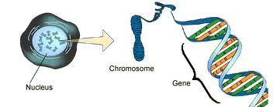
All living cells use the same genetic code based on 4 nitrogenous bases ______________, ______________, ________________ & ________________. The bases are grouped into genes. Each gene codes for the same _____________ acid in all organisms.
Even organisms that are very different such as _______________ and ______________ have large sections of ______________ which are the same. An example is the gene for ______________ ____________.
Organisms that seem to be similar using _______________ _________________ have more ______________ in common than those that are less alike. For example humans and chimps have ___% of their DNA in common. This can be seen as evidence supporting evolution because ________________________________________________________________________________________________________________________________________________________________________________________________
Amino Acids in a chain
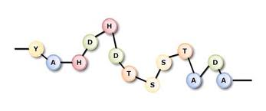
Proteins are made out of ________ __________ like a chain of beads. The order of the amino acids is controlled by ___________. The more of the sequence two organisms have in common the more closely related they are. An example of where this is used to see how closely related two species are is ________________________________________________________________________________________________________________________________________________________________________________________________________________________________________________________________
More than one protein needs to be studied before you can make reliable judgements about ________________________________________________.

